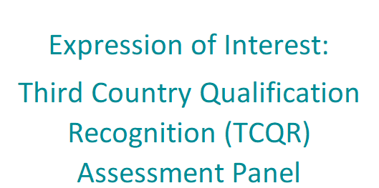  
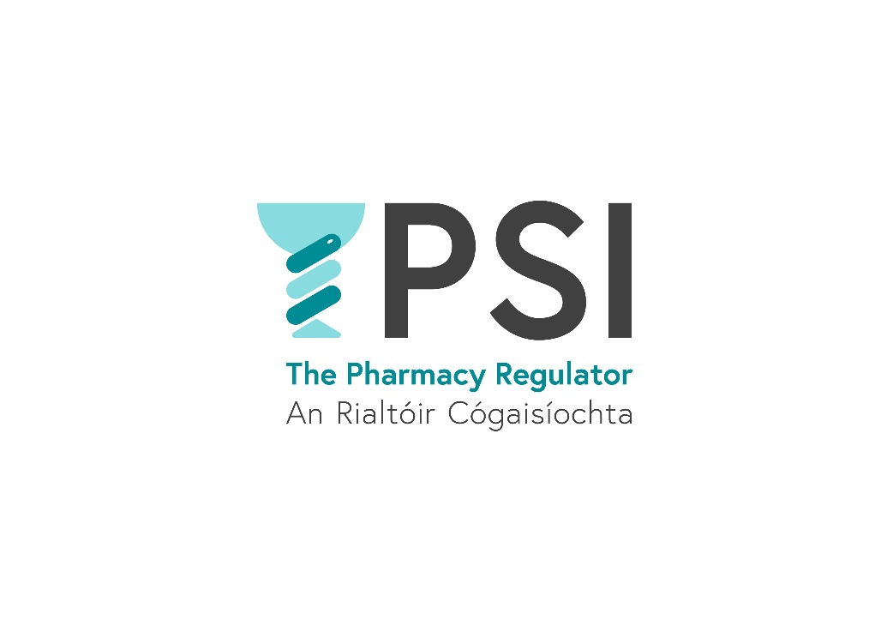

Closing date: Friday, 24 January 2025

Version 1.0

December 2024

Introduction

The Pharmaceutical Society of Ireland (PSI), the pharmacy regulator, is inviting expressions of interest from suitably qualified applicants to establish a panel of assessors who will assess applications under the revised Third Country Qualification Recognition route (TCQR).

Background

Pharmacists wishing to practise in Ireland must be registered with the PSI. The PSI must be able to verify that the standard of a pharmacist’s qualification and training meets the standard necessary for practice in Ireland in the interest of public protection.

Pharmacists who qualify in a non-EU or non-EEA country and wish to practise in Ireland must first have their qualification recognised as appropriate for practice before they can apply to register with the PSI via the TCQR route. In October 2022, the PSI Council considered and approved a revised TCQR process, which includes a holistic assessment of an applicant’s qualification. The revised TCQR route will have four main stages:

**Stage 1:** Validity of Application (screening stage/ preliminary review)

**Stage 2:** Paper- Based Assessment of Documentation by an external assessor

**Stage 3:** Examination to demonstrate equivalency (if applicable)

**Stage 4:** Issuing of Certificate of Qualification Appropriate for Practice

Applicants selected for the Panel of Assessors through this expression of interest process will carry out the paper-based assessment of TCQR applications under Stage 2 of the revised TCQR process.

The Stage 2 assessment comprises the following components:

1. The applicant’s pharmacy qualification(s) and in-service/practical training (**Input** components).
2. The quality components of the pharmacy regulatory system in place in the country where they qualified, for example, whether the applicant’s primary qualification was accredited (**Quality** components).
3. The applicant’s relevant post-graduate education, work experience and continuing professional development (**Output** components)

Submitting your interest

The PSI would like to invite applications from suitably qualified individuals interested in applying for the Panel of Assessors for the TCQR Route. If you have an interest in applying for the Panel of Assessors, please submit a completed application form via email to [eoitcqrassessor@psi.ie](mailto:eoitcqrassessor@psi.ie).

Please provide sufficient detail and information in your application form to facilitate your application being shortlisted in the first instance. Only information submitted on the application form may be accepted by PSI

Expressions of interest applications should be submitted no later than close of business on **Friday 24th January 2025.**

The PSI will initially establish a panel from this Expression of Interest. However, a supplementary panel may be formed to allow for vacancies to be filled as they arise. A further expression of interest process may be run in the future as and when additional assessors are needed.

Questions or clarifications about any aspect of this expression of interest process may be sent to [laura.irwin@psi.ie](mailto:laura.irwin@psi.ie) or [damhnait.gaughan@psi.ie](mailto:damhnait.gaughan@psi.ie).

Essential Selection Criteria for Assessor Panel

1. All applicants must be either a suitably senior/experienced registered pharmacist, **OR** be in a position to demonstrate entitlement to be so registered, **OR** have academic assessment experience relevant to the assessment of pharmacist or health sciences qualifications
2. All applicants must have experience in teaching and assessment at third level or experience of assessing non-national registration applications **OR** experience mentoring or tutoring pharmacists and pharmacy students or acting as a preceptor to pharmacy students **OR** involvement in assessment of pharmacists or pharmacy students, for example, during practice reviews or as an examiner.

The PSI is committed to a policy of equal opportunity, and we will endeavour to ensure diversity and balance on the Panel of Assessors.

Training

Training will be provided to successful applicants in advance of completing any assessments. A standardised proforma will be used to ensure consistency. Quality review, and periodic sampling along with double assessment may be used, along with other legitimate modalities to assess consistency.

Time commitment

It is envisaged that approximately 200 assessments in total will be completed annually. Assessments will be allocated as evenly as possible between each member of the assessment panel, taking into account availability and other factors.

**Payment**

Assessors will be remunerated for their work at a rate of €300 per assessment, and assessors will be required to invoice PSI for assessments conducted. All reasonable vouched expenses are discharged in line with the PSI’s travel and subsistence policy. Please note, as a public service body the PSI must give due consideration to the requirements of the One Person One Salary Directive, where applicable.

Data Protection

The PSI will process any personal information provided with expressions of interest in accordance with Data Protection legislation. The information will be kept for no longer than is necessary for its purpose, and it shall be kept in a manner that ensures appropriate security of the information, including the unauthorised or unlawful processing of it. Please review the Data Protection Statement on the PSI website for details of our use of personal information and your rights in relation to this.

Application Form

|  |  |
| --- | --- |
| 1. **Personal Details** | |
| Title |  |
| Forename |  |
| Surname |  |
| Telephone Number |  |
| Email Address |  |
| Correspondence Address |  |

|  |  |
| --- | --- |
| 1. **Professional Details (where applicable)** | |
| Are you currently registered with PSI? (Y/N)  (If yes please provide your registration number) |  |
| Are you currently registered with another Health and Social Care Regulator? (Y/N)  (If ‘Yes’ please provide the name of the regulatory body and registration number) |  |

|  |  |  |  |
| --- | --- | --- | --- |
| 1. **Education Details**   Please include copies of certificates for all qualifications that you have listed below | | | |
| **Title of qualification** | Date Qualification Obtained | Course Provider | Grade Obtained |
|  |  |  |  |
|  |  |  |  |
|  |  |  |  |
|  |  |  |  |

|  |  |  |
| --- | --- | --- |
| 1. **Employment History** (maximum of 500 words)   Please include employment history which is relevant to the application | | |
| **Dates of employment (To/From)** | Name and Address of employer | Position and Responsibilities |
|  |  |  |
|  |  |  |
|  |  |  |
|  |  |  |

|  |
| --- |
| 1. **Professional Experience** (maximum of 500 words)   Please outline the relevant experience you have to the role of assessor; this includes but is not limited to   * 1. *The number of years of experience in practice, outlining the range of issues encountered, management of MPharm student placements and general management experience, OR*   2. *The number of years’ experience in the Higher Education sector including; role, assessment experience, standard setting, and any publications or research completed in specific/relevant fields.* |
|  |

|  |
| --- |
| 1. **Assessment Experience** (maximum of 500 words)   (Please outline any relevant previous assessment experience gained with PSI or another similar body) |
|  |

|  |
| --- |
| 1. **Further Information** (maximum of 250 words)   **Please use this section to provide any further information that you feel may be relevant to your application** |
|  |

1. Declarations

Before you return this form please ensure that you have completed all sections of it and that you have completed the declaration below. The onus is on candidates to establish eligibility in this application form.

I hereby certify and declare that

(i) all of the information that I have provided on this application and in support of this application (documents, etc.) is valid and my statements have been honestly and accurately articulated to the best of my knowledge and belief.

(ii) I have not canvassed any member or employee of PSI. I have not asked anyone else to canvas on my behalf. I will not undertake seek or consent to any such canvassing.

(iii) I confirm that I have attached a statement of employment (or reference) from my current or most recent employer, which details the dates and duties of employment of my current role, confirming the duties that I have indicated above.

(iv) I confirm that I have attached a copy of my qualifications (if I am registered with a regulator other than PSI)(where applicable):

Yes ____ No ____ - if No, please detail why not ____________________________

Signature of Applicant: ____________________________________________

Date: _____________________________________________

Please ensure that you have provided all of the information for which you have been asked. Any person found to have given false information or to have wilfully suppressed any material fact will be liable to disqualification or, if appointed, to removal.

Please note that all personal data shall be treated as confidential in accordance with the Data Protection Act 2018 and the General Data Protection Regulation (Regulation 2016/679).